EDUCATION & CHILDREN’S SERVICES

IMPROVEMENT PLAN
2016 - 2017

FOR

UDNY GREEN SCHOOL

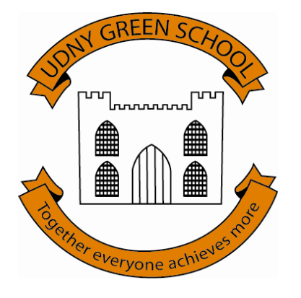

Aberdeenshire Council Education & Children’s Services

“Education & Children’s Services works to improve the lives of children and young people, families and communities through the delivery of high quality services across Aberdeenshire”

Udny Green School
Our vision is ….

"to enable all our learners to actively challenge themselves to achieve and attain their best on their journey to becoming successful learners, confident individuals, effective contributors and responsible citizens through planning, teaching, talking about, gathering and sharing evidence of excellent learning experiences."

E&CS Services

Aberdeenshire Council and Education and Children’s Services is committed to improvement through effective self-evaluation. The significant relationship between effective self-evaluation and school improvement can also be seen as an “inwards, outwards, forwards” approach to help you and your partners answer the questions which remain at the heart of
self-evaluation:
- How are we doing?
- How do we know?
- What are we going to do now?

Effective self-evaluation involves a level of reflection and critical enquiry which is best achieved through a blend of internal and external analysis. Making sound judgements about the impact on learners should be central to self-evaluation.

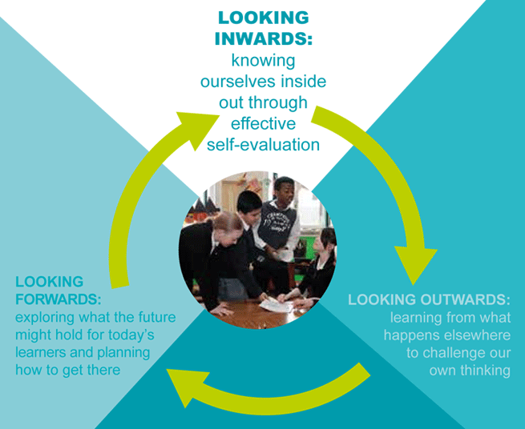

The priorities for improvement contained in the Improvement Plan for 2016 – 17 reflect this process and the priorities identified locally and nationally.

Improvement Focus No. | 1 | Leadership and Management
Identified Theme  (From S&Q / Self-Evaluation) |  | - Self evaluation and improvement – Themes: Collaborative approaches to self evaluation; Analysis and evaluation of intelligence and data; Ensuring impact on learners’ successes and achievements  1.3 Strategic planning for continuous improvement
Actions |  |  | Intended Outcome (s) / Impact | How will you measure success?
Formulate a calendar of quality assurance activities for all stakeholders against the new quality indicators.  Evaluate improvement progress against the new CfE implementation plan and identify priorities.  Form parent/community group to develop and steer effective consultation with stakeholders to ensure everyone is involved in our on-going self-evaluation activities. (Focus for consultation – literacy strategy)  All stakeholders to familiarise themselves with new benchmarks for literacy and numeracy  Termly analysis of PIPS and INCAS data; literacy and numeracy attainment data and termly targets against new benchmarks.  All stakeholders involved in termly profiling and reporting on identified significant aspects of learning to evidence benchmarks.  Attainment data moderated with cluster colleagues  Attend SLF, teachmeets, listen to Twitter, follow activity of international educationalists panel to access research and reflect on current practice  Evidence how stakeholders views lead to change and improvement |  |  | Effective collaborative approaches to self evaluation  Effective analysis and evaluation of intelligence and data  Shared understanding of the school’s strengths and improvement needs.  Learner statements and learning log posts will demonstrate that learners are reflecting on attainment evidence and actively challenging themselves to improve.  Data and views will inform strategic planning for continuous improvement | Evaluation of impact/actions of parent/community group  Evaluation of impact/actions of Pupil Council and Parent Council  Increased participation evidenced by increased number of comments, votes, suggestions contributed.  Display inward, outward and forward actions/approaches to monitor improvement activities and evidence of increased participation  Revised Quality Assurance Calendar  Standards and quality report will provide a strategic plan for continuous improvement.

Evidence of Progress / Comments / Next Steps
Date
Date
Date:

Improvement Focus No. | 2 | Learning Provision (Including Improving Transitions)
Identified Theme  (From S&Q / Self-Evaluation) |  | 2.3 Learning, teaching and assessment – Themes – Learning and engagement; Quality of teaching; Effective use of assessment; Planning, tracking and monitoring  2.6 Transitions – Theme – Collaborative planning and delivery; Continuity and progression in learning
Actions |  |  | Intended Outcome/ Impact | How will you measure success?
To identify methodology, tools and resources to improve pedagogy - how we teach and assess.  Participate in the Tapestry formative assessment programme.  Attend visible learning conference  Professional learning – Read and discuss chapters from Shirley Clarke’s Outstanding Formative Assessment – Culture and Practice  Review planning for learning and ongoing assessment/reporting calendar and approaches in light of advice from Chief HMIE Officer. |  |  | Learners can talk about what they are learning about/to do and they can do this successfully. (learning intentions and success criteria)  Teachers use questioning and talk partners to encourage deep thinking and to provide evidence of learning. (Quality questioning)  Teachers give feedback in a way that identifies strengths and supports improvements in an ethos where errors are welcome (Improvement feedback)  Learners can reflect on evidence of their learning and plan for next steps | Plans for learning is manageable, relevant for all involved.  Learning visits/rounds – Term 2 HT (focus literacy and social studies) ; Term 3 Colleague (focus maths and expressive arts/technologies); Term 4 Cluster colleague (focus health and wellbeing)  Learning conversations – HT to meet with a different group of children each term to ask them to talk about and share evidence of what they have been learning about, how they have learned and what they need to learn to do next.  Learner statements will contain strengths, areas for improvement and plan for next steps  P7 profiles

Evidence of Progress / Comments / Next Steps
Date:
Date:
Date:
Date

Improvement Focus No. | 3 | Success and Achievements
Identified Theme  (From S&Q / Self-Evaluation) |  | 3.2 Raising attainment and achievement – Themes - Attainment in literacy and numeracy; Attainment over time; Overall quality of learners’ achievement; Equity for all learners 3.3 Increasing creativity and employability – themes – creativity skills; digital innovation; digital literacy; Increasing employability skills
Actions |  |  | Intended Outcome/ Impact | How will you measure success?
Agree, write and publish a clear strategy for raising attainment in literacy in consultation with all stakeholders  Undertake SSLN Professional learning literacy workshops  Listening and talking Term 2  Reading Term 3  Writing Term 4  Gather evidence of attaining benchmarks  Moderate understanding of benchmarks with cluster colleagues  Develop monitoring and tracking approaches  Development of resources and guidance  Attend dyslexia inservice day course and complete ALDO training (see cluster improvement plan)  Apply for a Scottish digital school award |  |  | Learning logs provide evidence of children’s journey to attaining benchmarks  Learning targets are progressing achievement  Children can talk about how much and how well they are learning in literacy and what they need to learn to do next,  Working towards becoming a Dyslexia Friendly School  Clear strategy for raising attainment in literacy written, consulted upon with all stakeholders, reviewed and published in Term 4.  Scottish Digital School Award achieved | Consult with parent improvement planning group, parent council and pupil council to gather their views of the strategy.  Dyslexia screening assessment completed, data analysed and plans for support written.  HT Learning conversations with learners about literacy learning approaches and the literacy strategy.  Learners to provide feedback on quality of literacy learning experiences

Evidence of Progress / Comments / Next Steps

Date
Date
Date:
Date

